**OBJECT ORIENTED PROGRAMMING (PCC-CS503)**

**Unit – 6**

**Generic Programming**

* Generic Programming is a style of computer programming that enables the programmer to write a general algorithm (function/class) which will work with all data types.
* It eliminates the need to create different algorithms for different types of data.
* Algorithms are written in terms of types *to-be-specified-later* that are then *instantiated* when needed for specific types provided as parameters.
* The advantages of Generic Programming are:
  + Code Reusability
  + Avoid Function Overloading
  + Once written it can be used for multiple times and cases.

Template concept

* Templates help implementing generic programming.
* A single class or a function can work for different data types using templates.
* Generic programming is a technique where generic types are used as parameters in algorithms so that they can work for a variety of data types.
* Templates can be represented in two ways:
* Function templates
* Class templates

Function template

* Generic functions use the concept of a function template. Generic functions define a set of operations that can be applied to the various types of data.
* The type of the data that the function will operate on depends on the type of the data passed as a parameter.
* For example, Quick sorting algorithm is implemented using a generic function, it can be implemented to an array of integers or array of floats.
* A Generic function is created by using the keyword template. The template defines what function will do.

Syntax:

template <class T> T func_name(parameter_list)

{

    // body of function.

}

**T**: It is a placeholder name for a data type used by the function. It is used within the function definition. It is only a placeholder that the compiler will automatically replace this placeholder with the actual data type.

**class**: A class keyword is used to specify a generic type in a template declaration. It can also be replaced by keyword **typename**.

Example:

#include <iostream>

using namespace std;

template<class T, class X>

T add(T a, X b)

{

T result = a+b;

return result;

}

int main()

{

int i =2;

int j =3;

float m = 2.3;

float n = 1.2;

cout<<"Addition of i and j is: "<<add(i,j);

cout<<'\n';

cout<<"Addition of m and n is: "<<add(m,n);

return 0;

}

O/P:

Addition of i and j is: 5

Addition of m and n is: 3.5

**How templates work?**

Example 2:

#include <iostream>

using namespace std;

// One function works for all data types. This would work

// even for user defined types if operator '>' is overloaded

template <typename T>

T myMax(T x, T y)

{

return (x > y)? x: y;

}

int main()

{

cout << myMax<int> (3, 7) << endl; // Call myMax for int

cout << myMax<double>(3.0, 7.0) << endl; // call myMax for double

cout << myMax<char>('g', 'e') << endl; // call myMax for char

return 0;

}

O/P:

7 7 g

Templates are expanded at compiler time. Compiler does type checking before template expansion. The idea is simple, source code contains only function/class, but compiled code may contain multiple copies of same function/class.

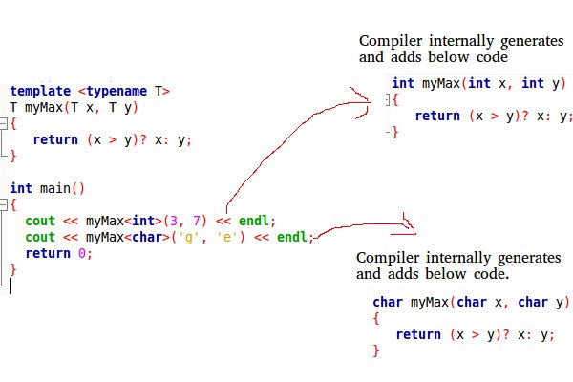

NOTE: We can define more than one generic data type using a comma-separated list.

Class template

**Class Template** can also be defined similarly to the Function Template. When a class uses the concept of Template, then the class is known as generic class.

Syntax:

template<class T> class class_name

{

  .

  .

}

**T:** is a placeholder name which will be determined when the class is instantiated. We can define more than one generic data type using a comma-separated list. The T can be used inside the class body.

Now, we create an instance of a class

Syntax:

class_name<type> ob;

**class_name**: It is the name of the class.

**type**: It is the type of the data that the class is operating on.

**ob**: It is the name of the object.

**Example:**

#include <iostream>

using namespace std;

template<class T > class A //creating the generic class

{

public:

T num1 = 5;

T num2 = 6.5;

void add()

{

std::cout << "Addition of num1 and num2 : " << num1+num2<<std::endl;

}

};

int main()

{

A<int,float> d; //creating instance of the generic class

d.add();

return 0;

}

O/P:

Addition of num1 and num2 : 11